HW4.2 Centroids of Complex Shapes
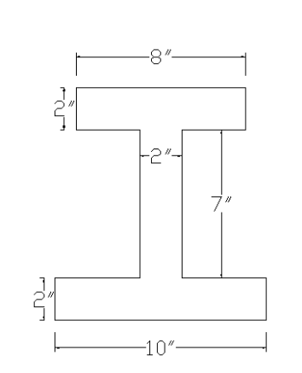
Find the centroid (x̄, ȳ) of the composite shape shown.

Given Dimensions
Bottom flange: 10 in × 2 in
Web: 2 in × 7 in
Top flange: 8 in × 2 in

Step 1: Break the Shape into Rectangles
1 = Bottom flange
2 = Web
3 = Top flange

Step 2: Table
Shape Area (A) Centroid y A·y
1
2
3
Total ΣA = _____________ Σ(A·y) = _____________

Step 3: Calculate y-bar
ȳ = Σ(Ay) / ΣA

ȳ = _____________ in

Step 4: Find x-bar
Is the shape symmetric? Yes / No
x̄ = __________ in

Final Answer
(x̄, ȳ) = (__________, __________)

